How To Create an EC2 Instance

Step1🡪 Open AWS EC2 Dashboard Click on Launch instance

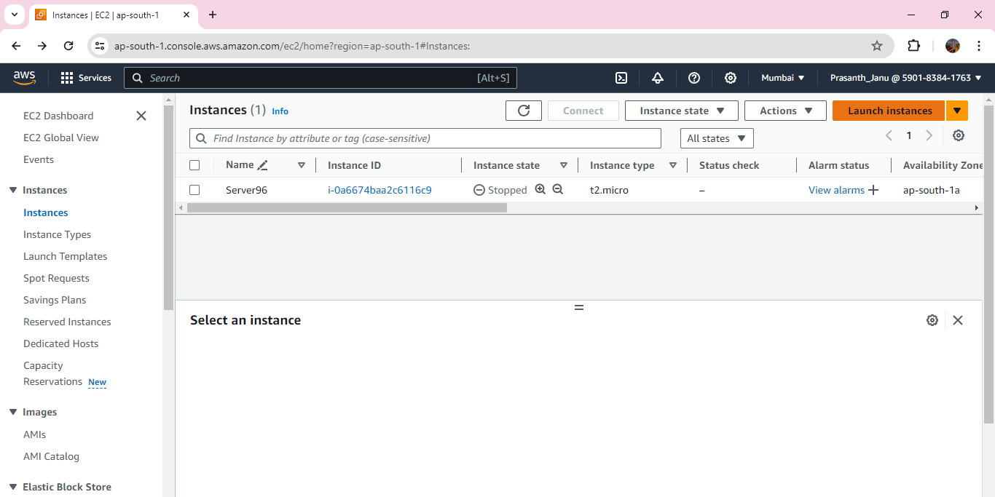

Step2🡪 After Clicking On Launch instance you will see a options

Specify the name and select particular AMI (AWS Linux, Ubuntu etc)

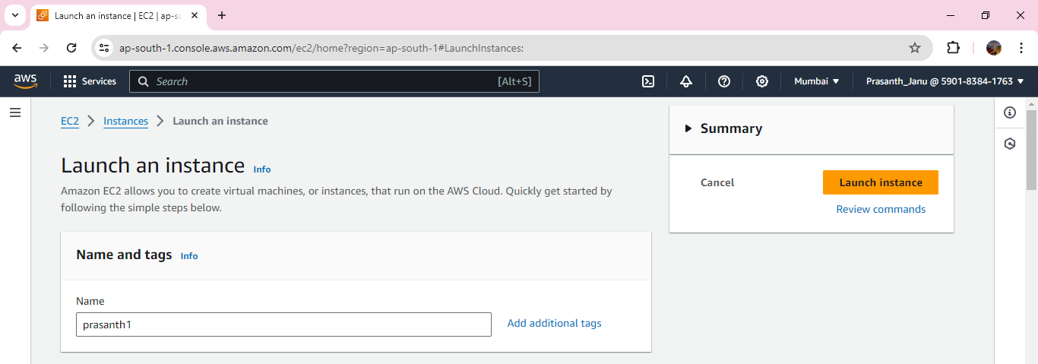

Step3🡪 Select 64-bit (*86)

Step4🡪 key pair (login)

You can use a key pair to securely connect to your instance. Ensure that you have access to the selected key pair before you launch the instance.

Is there any key pair select an default one otherwise click on create a new key pair and save it to desktop,

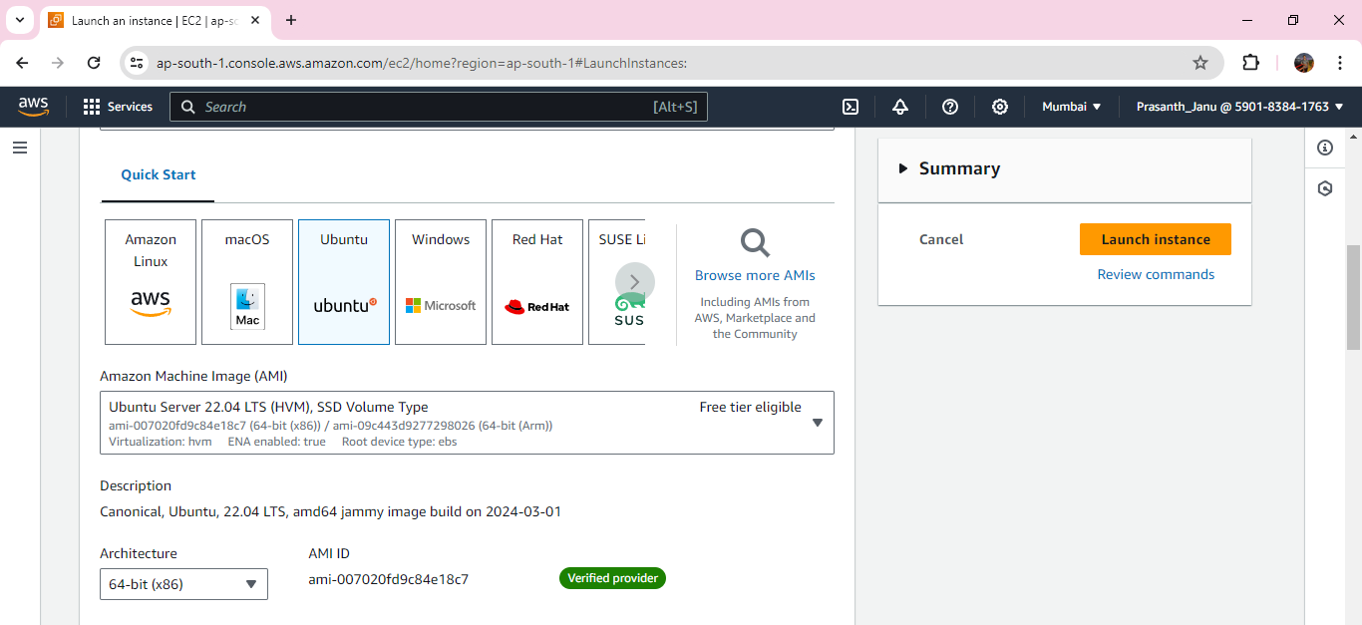

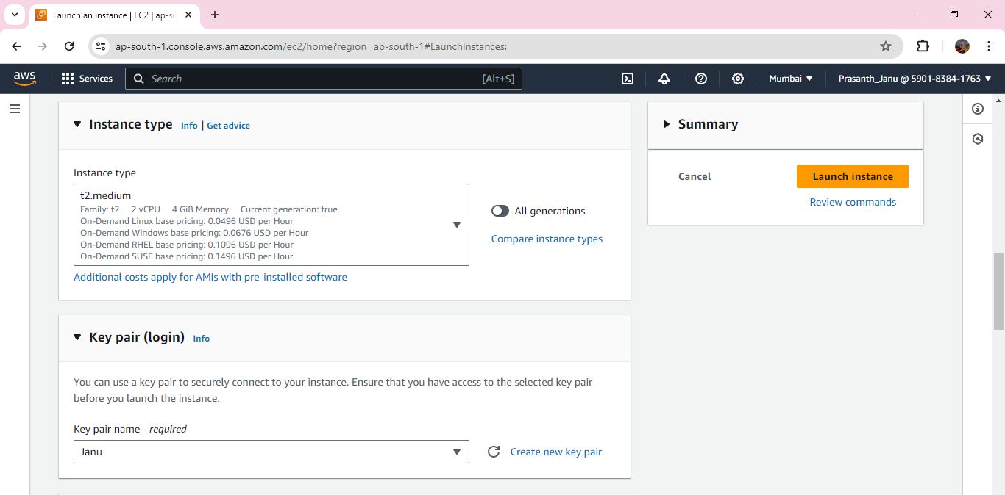

Step5🡪Select Network settings and click on edit

Select VPC and select subnet as per zone availability

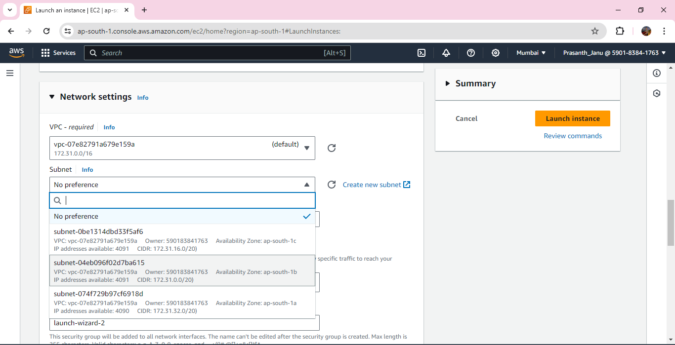

##### Step6🡪 Security group name and assign a Inbound Security Group Rules

##### C:\Users\HP\Pictures\Screenshots\Screenshot (233).png

##### Step7🡪 Give the configure storage as per project requirementC:\Users\HP\Pictures\Screenshots\Screenshot (234).png

##### Step8🡪 At last click on Launch Instance and go back to resource

##### Check either instance in Running State and 2/2 check passed.

##### 

##### Step9 connect the instance by clicking connect and select ssh client copy it

##### 

##### Step10 after connecting we need to install webserver

##### Webserver software that is responsible for accepting HTTP requests from visitors and sending them back he requested information in the form of web pages

##### It allows visitors to view content on your website

##### Commands to install webserver

##### Sudo apt update

##### Sudo apt install nginx

##### Sudo service nginx start

##### Sudo service nginx status

##### Step11 after installing webserver need to check the webpage by instance ip address